Margareth Yvonne De Ramos March 5, 2026
BSHM -1C
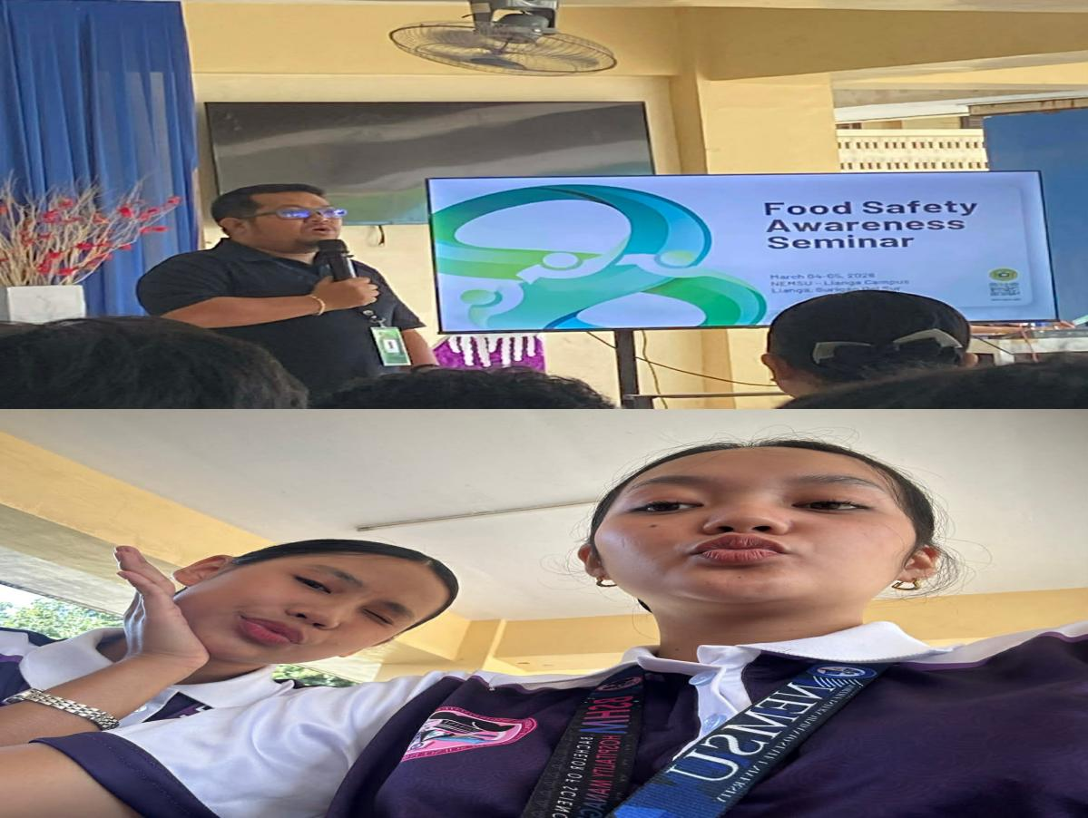
Reflection on Food Safety and Sanitation

The community health protection which I studied through food safety and sanitation proved to be essential community health protection method.The discussion showed me that food safety involves more than just cooking food because I had thought that only cooking food properly formed its boundaries.The definition of food safety extends beyond proper food handling and storage practices to include essential Cleanliness requirements and personal hygiene standards which protect against food contamination and foodborne diseases.Food safety ensures that the food people eat will not cause harm when it is prepared and consumed according to its intended use.The first thing that I noticed about unsafe food was its extreme dangerousness. Contaminated food contains harmful bacteria and viruses and parasites and chemicals which lead to various illnesses including diarrhea and infections and serious diseases. The global foodborne disease outbreak affects millions of people per year according to my research which showed that diarrheal diseases rank as one of the main causes of death for communicable diseases. Proper food safety practices must be followed by food establishments yet they also need to be practiced by every person.The discussion also included another essential subject which examined the need for sanitary permits that food establishments must obtain. The sanitary permit functions as verification that a food establishment has successfully completed its inspection process while maintaining required sanitation standards.The regulation ensures that food handlers must complete medical evaluations which verify their health status and protect against foodborne contamination.
I learned from this lesson that food safety is a responsibility that individual persons have to take upon themselves to protect.

